**Team Members:**

Lincoln Lin: 3033156284

Yao Yuan: 3033156258

Yidan Zhang: 3033156414

Yifu Guo: 3033177214

**Reflection on Data Collected from Conceptual Use Study**

The users liked the “gamification” aspects of both of our traditional and dark horse prototypes. They thought it was a fun way to get motivated to use the platform. On the flip side, however, because we give users specific scores in the traditional prototype, and tangible money in the dark horse prototype, there may exist motivation to “game the system” to just get a good score or extra cash without actually getting the benefit of being exposed to more diverse views. Such inclination is especially strong in our dark horse prototype given that they are playing with real money and diminish the actual experience. Given this realization, we believe keeping the “bias score” to help users be more aware of the amount of bias they may have been exposed to is the more reasonable way to go.

The way that pages in our traditional and dark horse prototypes are laid out played a big difference in the time it took for the user to start a chat with another user. In the traditional prototype, the users to more drawn to read different new articles first before realizing they could actually talk with other users on the platform. On the contrary, the fact that we prompt the user to pick a side on any given topic leads them more naturally to explore talking with others who hold different views in the dark horse prototype. To be more specific, when we asked the user to explore our prototypes and try to start a conversation with another user, it took them on average 58 seconds to land on a chat in the traditional prototype, whereas it only took them 38 seconds in the dark horse prototype. Given that our goal is to encourage college students to share views with more people with different perspectives, we think that encouraging users to quickly find and use the “chat” functionality of our prototype is very important. Therefore, we plan on incorporating in our final prototype the concept of allowing users to see and pick from a list of trending political topics on the home page, pick a side that he/she is on for that topic, and eventually see and be able to chat with others who hold the opposite opinion.

The decision to incorporate the “side picking” feature from our dark horse prototype also came from the realization that people are more likely to initiate a chat with other user if they are given a particular topic to talk about already. In our traditional prototype, users can initiate a chat with any other user that they would like. They are motivated to talk with those who have an opposite score in order to balance their own, or the system will periodically challenge them to do so. What we learned during study, however, is that when only given this context, users actually didn’t know what to say at first to start a conversation. Without a pre-set topic that is related to politics (what we want our users to get more exposure to), conversations are more likely to degrade to general ones where they may just chat to get a better score or more money.

Another thing we learned about the “bias score” mechanism is that it may be confusing to many people. More specifically, in our design, positive and negative score simply means different political leaning, with larger absolute values indicating heavier bias. To many users, however, they tend to associate negative scores with bad connotation and avoid reading articles or chat with other users who have negative scores. We tried to explain this mechanism and how scores are calculated/evaluated when the user first interact with the platform, but most of them found the long explanation at the beginning cumbersome and skipped it.

To mitigate this confusion, we plan on inserting short “reminders/tooltips” at places where users may need to interact with “bias scores” rather than front loading all the information at the beginning. To be more specific, on the chat page, we may show a banner that says “Chat with users with opposite scores to be more balanced!”. Next to a page of news articles with negative scores, we may say “Read these articles to balance your scores. They will help you!”. We think indicators will help users gradually learn the actual meaning of the positive and negative scores over time without being pressed to learn everything at the very beginning.

**Data Collected (From P4)**

**Survey questions (Likert Scale questions):**

1. Which prototype do you think is easier to use?
   1. A is much easier A is somehow easier About the same
   2. B is somehow easier B is much easier
   3. Why?
2. Which prototype can help people better to get exposed to diverse opinions?
   1. A is much better A is somehow better About the same
   2. B is somehow better B is much better
   3. Why?
3. Which prototype do you prefer to use?
   1. A is much better A is somehow better About the same
   2. B is somehow better B is much better

**Items measured**

1. Time consumed to start a chat
2. Places where errors are made
3. Places where users get stuck

**Cycle 1**

1. Traditional Prototype
   1. Time consumed to start a chat: about 58s
   2. The user is confused about what the score means and is reluctant to talk to users with negative score because he think negative score is a sign of “bad conversation”.
   3. Users are clear about how to proceed to the feature they want.
   4. Users are thinking about how long they should talk and how concrete the content should be in order to receive rewards.
2. Dark Horse Prototype
   1. Time consumed to start a chat: about 30s
   2. When users first open the application, they were kind of intimidated by the amount of explanation on the front page.
   3. They were really interested in the mechanism explanation (especially related to reward and penalty).
   4. They would like to know all the possible chatting candidates, not just the ones we recommend.
   5. Great interest in how to spend the money on the balance.
   6. For each page, they have no problem to find out what the page is about and what they should do next

Survey questions:

1. They think Dark Horse prototype was easier to use. They were trapped in the cycle of reading articles when playing around with traditional prototype. Also the article reading function and chatting function of traditional prototype were so isolated that the users were confused about the relationship between them.
2. They think Dark Horse prototype was better to help users to get exposed to diverse opinions because users will be more motivated while using the dark horse prototype.
3. They preferred to use Dark Horse prototype.

**Cycle 2**

1. Traditional Prototype
   1. Time consumed to start a chat: about 45s
   2. Users are able to browse articles or start a chat without any guidance.
   3. The user doesn’t notice their score until prompted by us.
   4. Similar to the previous cycle, users are confused about our score system.
2. Dark Horse Prototype
   1. Time consumed to start a chat: about 18s
   2. They didn’t have the patience to go through the explanation on the front page.
   3. On the later pages, they were confused about how the overall mechanism works.
   4. They were curious about how much money one can possibly win or lose for each round/topic.
   5. They felt that they would use the application only if the instructors were told them to do so.
   6. They had no problem on proceeding from one page to another.

Survey questions:

1. They think Dark Horse prototype was easier to use. They weren’t trapped when playing around the traditional prototype, but they spent too much time on the reading article part. They also quite don’t understand the relationship between the article reading function and chatting function.
2. They think the users of Dark Horse prototype will be more motivated to use that just because users could earn money from it. The motivation of earning money may be higher than the motivation of getting exposed to diverse opinions.
3. They preferred to use traditional prototype because Dark Horse prototype will guide people to earn money, and if Dark Horse is no longer using money, and use score instead, it will be less attractive than the traditional prototype.

**Define Final Prototype Design concept**

We will develop a web application that allow users to chat with others who hold different opinions on given topics as well as browsing news articles politically influenced by different parties on the platform. Each user on will be assigned a “bias score”, which is calculated by a combination of the article he/she browses as well as the people he/she chat with.

To prompt users to chat with others and give them an easy way of initiating conversations, we will provide a list of trending political topics on the front page everyday. The users can click on any of these topics, and they will then be prompted to pick their side/viewpoint on the chosen topic. After this, the user will be able to see others who had chosen different perspectives and will be prompted to start conversations with those users to talk about the given topic. This will help set the tone of the conversation and encourage them to chat with more people. Depending on the number of people a given user talk to and the length of the conversations, the user’s bias scores will be updated to reflect his/her recent activities.

Another way for users to balance their “bias score” is to browse articles with different perspectives. Each article on the platform is assigned a “bias score” depending on its political leaning. For example, an article influenced by the left will have a positive score, and the value of the score depends on how heavily influenced the article is. An article influenced by the right will in turn have a negative score. When users browse these articles, the scores associated with these articles are added to the users’ scores. A very high or very low bias score indicates that the user may have been exposed to articles with the same political leaning and therefore indicate bias. This information is also viewable to all other users on the platform, so in addition to serving as a reminder for the user him/herself to explore articles from the opposite opinion, it also create a sense of peer pressure for users.

**State diagram**

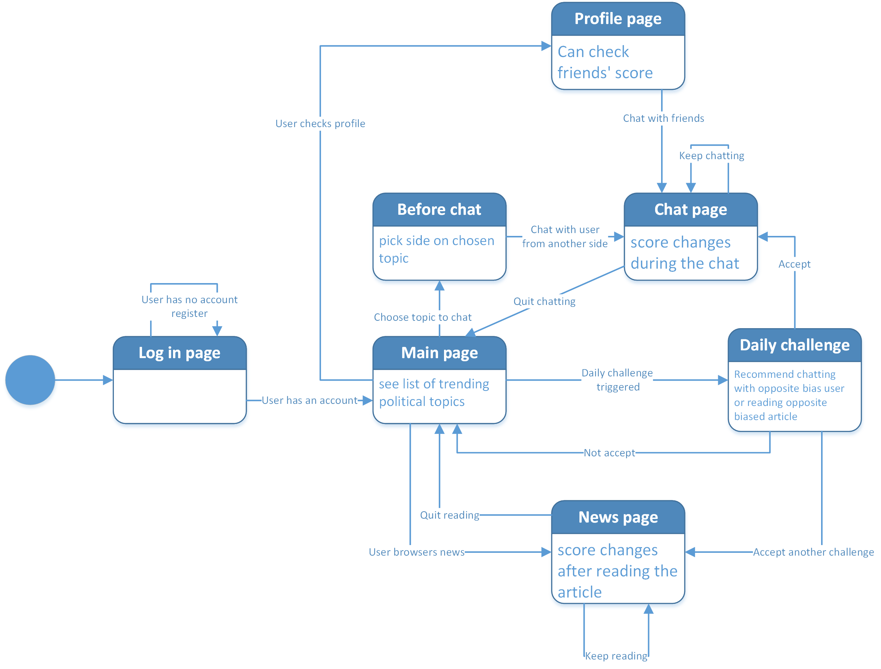

Explanation：

We have implemented the following states:

1. Log in page
2. Before chat, pick side on chosen topic
3. Semi-completed main page (without topic list)
4. Interactive Chat Page (with scores update and real time functioning chat)
5. News page (with score change after users have read the news)

Need to do:

1. Finish Main page
2. Check friends’ score
3. Daily Challenge
4. Furnish Profile page

[**Link to the video**](https://drive.google.com/a/berkeley.edu/file/d/1mOtdtJjqUlo6LKSU9DcXt7QvlyyOw4av/view?usp=sharing)

[**Link to GitHub**](https://github.com/jeffgyf/P5)